COVID-19 Trash & Recycling FAQ

Please help us keep our community clean and safe and protect recycling workers!

What should I do with these items?

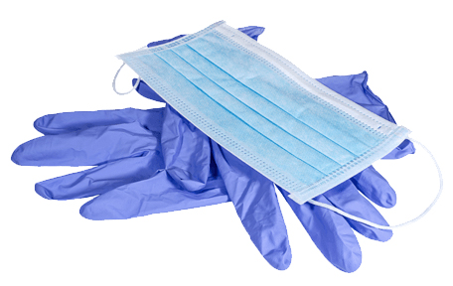 | Disposable masks and gloves  Personal protective equipment like masks and gloves belong in the garbage. They cannot be recycled. As litter on streets and parking lots, they get blown and washed into creeks and the Bay.  Tip: Keep a sealable plastic bag with you for your used gloves and mask, then dispose when you get to a trash can.
Disposable wipes
Please do not throw disposable wipes into the toilet. They do not break down like toilet paper and can clog pipes and cause backups. Even if the packaging says “flushable” or “compostable,” they belong in the garbage.
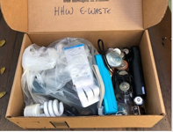 | Household batteries, e-waste, and fluorescent bulbs  These items need special disposal and do not belong in the garbage. However, many facilities that typically accept these materials are closed or have reduced hours. Please hold on to them until drop-off facilities reopen!
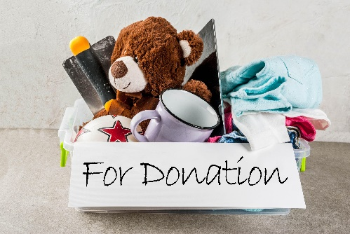 | Unwanted items  Cleaning out? You may want to designate an area or clearly labeled boxes to save items that need to be donated or discarded once stay-at-home orders are lifted. Most donation drop-off sites are closed, and bulky item collections are on hold in most cities.
What else can I do to help?
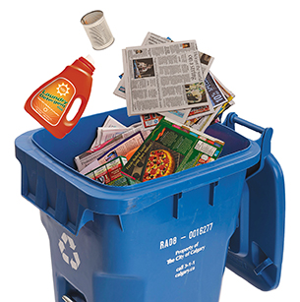 | Properly separating recyclable and compostable materials from garbage is now more important than ever! Please help minimize exposure for recycling workers by placing materials into carts and bins loose (not in bags), breaking down cardboard, and rinsing or wiping out recyclable containers.

Questions? Email info@recyclingrulesac.org

For more tips, follow StopWaste at:
www.facebook.com/stopwasteorg and www.instagram.com/stopwaste

